

Please use this form for both the:

Claude Hannoun prize for Best Body of Work
ESWI Innovative Award

1. Personal information

Name:
Date of birth:
Nationality:
e-mail address:

2. Employment history

3. Education and qualifications

4. Executive summary of work
maximum of 1,000 words

5. Influenza-related publications

AND/OR

6. Vaccine development publications

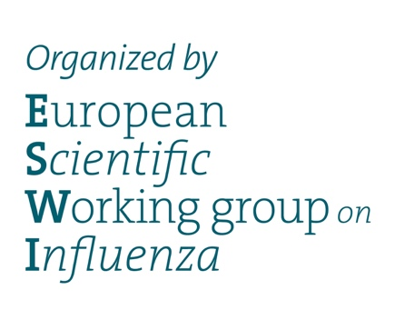
Submit your application and proof of status (mandatory)
to info@eswi.org before 30 June 2021

